Kiribathgoda
Experiments for Kiribathgoda | Balanced  Accuracy | Testing accuracy | Training accuracy | precision | recall | F1 score | Confusion matrix | Feature imporatance
Basic  XGB |  | 81.82 | 100 | 50 | 25 | 33.33 | 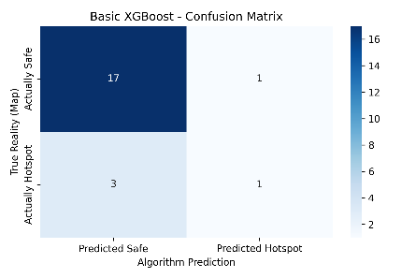 | 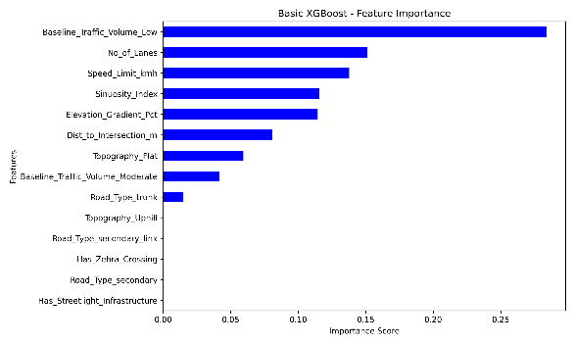
Tuned  XGB  'max_depth': 3, 'n_estimators': 100 |  | 81.82 | 100 | 50 | 25 | 33.33 | 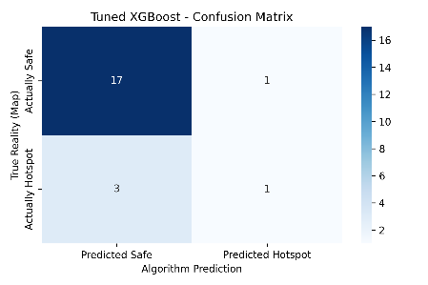 | 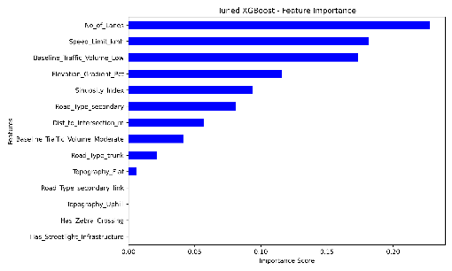
With SMOTE  'smote__  sampling_  strategy': 0.7,  'xgb__  max_  depth': 3, 'xgb__n_  estimators': 200 |  | 72.73 | 100 | 25 | 25 | 25 | 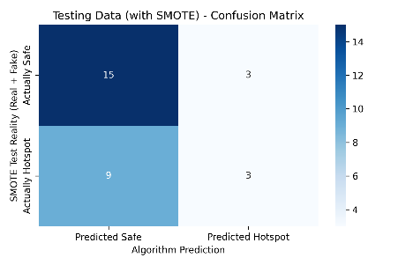 | 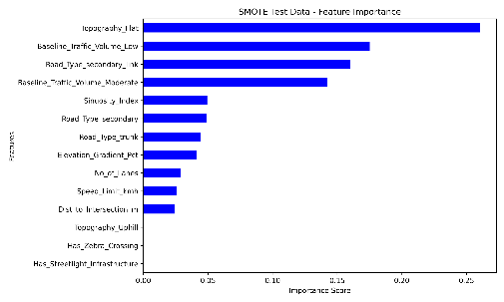
After tuning  With smote  'smote__  sampling_  strategy'  : 0.3,  'xgb__  max_  depth'  : 3, 'xgb__  n_  estimators': 300 |  | 81.82 | 100 | 50 | 25 | 33.33 | 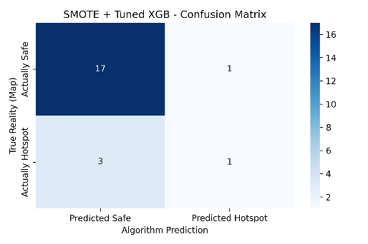 | 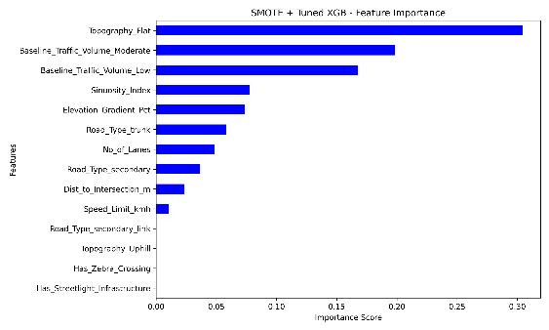
After tuning  With BO smote  'xgb__colsample_  bytree': 0.987, 'xgb__learning_  rate': 0.0138, 'xgb__max_  depth': 7, 'xgb__n_  estimators': 274, 'xgb__subsample': 0.779 |  | 72.73 | 94.32 | 33.33 | 50 | 40 | 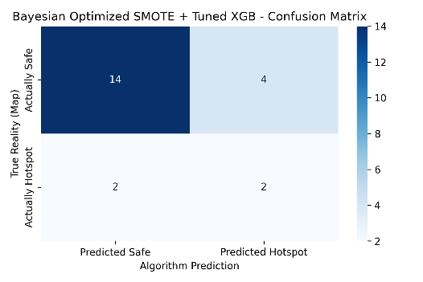 | 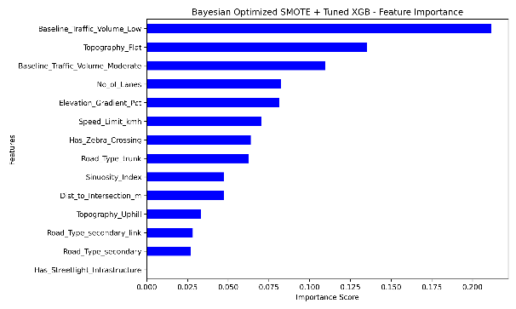
Experiments for Ella | Balanced  Accuracy | Testing accuracy | Training accuracy | precision | recall | F1 score | Confusion matrix | Feature imporatance
Basic  XGB |  | 75 | 100 | 26.67 | 36.36 | 30.77 | 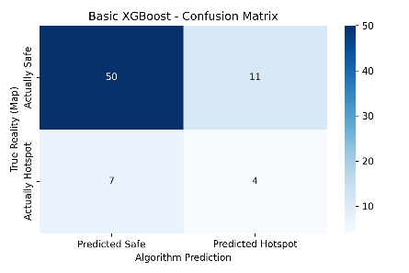 | 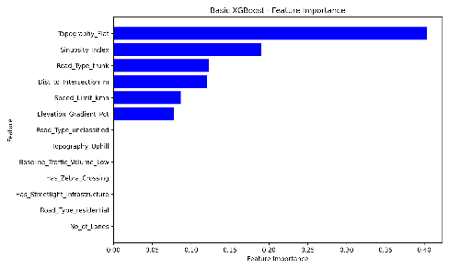
Tuned  XGB  'max_depth': 5, 'n_estimators': 100 |  | 73.61 | 100 | 21.43 | 27.27 | 24 | 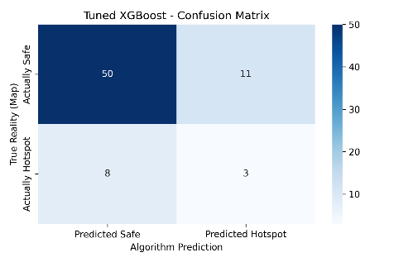 | 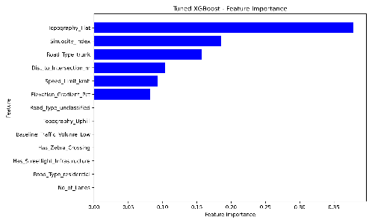
With SMOTE
After tuning  With smote  'smote__sampling_strategy': 0.7, 'xgb__max_depth': 3, 'xgb__n_estimators': 200 |  | 77.78 | 100 | 20 | 20 | 20 | 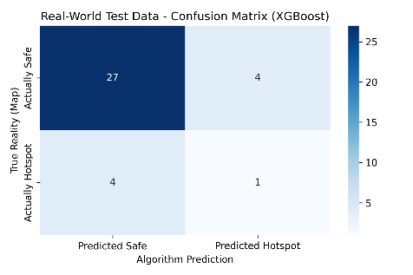 | 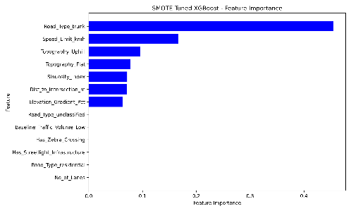
Anuradhapura
Experiments for Anuradhapura | Balanced  Accuracy | Testing accuracy | Training accuracy | precision | recall | F1 score | Confusion matrix | Feature importance
Basic  XGB |  | 87.40% | N/A | 16.67% | 8.33% | 11.11% | 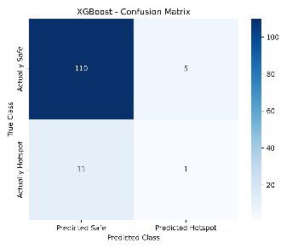 | 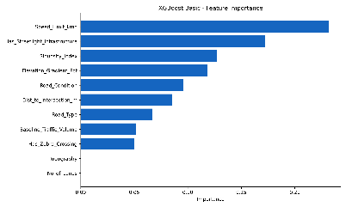
Tuned  XGB  'max_depth':3 , 'n_estimators': 300 |  | 85.38% | 100.00% | 6.67% | 4.17% | 5.13% | 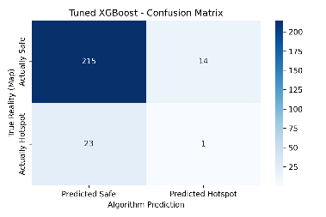 | 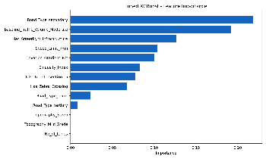
With SMOTE

After tuning  With smote  'smote__  sampling_  strategy'  :0.5 ,  'xgb__  max_  depth'  : 3, 'xgb__  n_  estimators':100 |  | 77.95% | 94.05% | 13.64% | 25.00% | 17.65% | 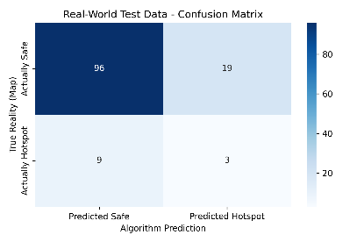 | 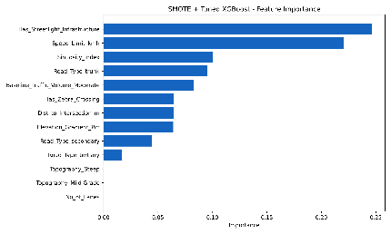
After tuning  With BO smote  'xgb__colsample_  bytree':0.759, 'xgb__learning_  rate':0.168, 'xgb__max_  depth':4 , 'xgb__n_  estimators': 349, 'xgb__subsample': 0.779 |  | 81.10% | 100.00% | 7.14% | 8.33% | 7.69% | 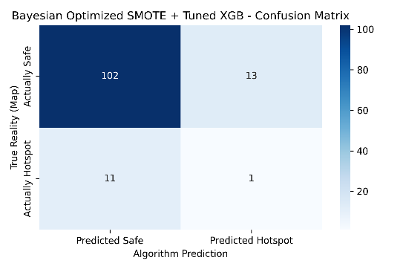 | 